600 First Street, Maysville, OK 73057—9551

405-867-5595 Fax: 405-867-4864

Elementary Address: 901 Oak, Maysville, OK 73057

BA/SB Concession Address: 507 10th St., Maysville, OK 73057

Fieldhouse Address: 509 10th St., Maysville, OK 73057

Football Field Address: 607 10th St., Maysville, OK 73057

High School Address: 600 1st Street, Maysville, OK 73057

**STANDARD EMERGENCY**

**OPERATING**

**PROCEDURES**

PREPARED IN COOPERATION WITH

THE STATE OF OKLAHOMA

DEPARTMENT OF EMERGENCY MANAGEMENT

APPROVED

July 2011

UPDATED

June 2024

MAYSVILLE PUBLIC SCHOOLS

STANDARD EMERGENCY OPERATING PROCEDURES

TABLE OF CONTENTS

Contents

INTRODUCTION 4

POLICY 4

SCOPE 4

PURPOSE 4

GENERAL 5

I. Situation and Assumptions: 5

A. Situation: 5

B. Assumptions: 5

II. Emergency / Disaster Operational Phases: 5

A. Preparedness: 5

B. Warning: 6

C. Response: 6

D. Post Emergency / Recover: 7

III. Organization and Responsibilities 7

A. Superintendent, Maysville Public Schools: 7

B. School District Emergency Manager 8

C. School Principals: 9

D. Teachers and Designated Administrative/Support Staff: 9

E. Students and Employees: 10

GENERAL RESPONSE PROCEDURES 10

I. Notification & Warning: 10

II. Evacuation or Sheltering: 10

III. Personnel Accountability: 10

IV. Restoration of Operations and Services: 11

EMERGENCY SPECIFIC RESPONSE PROCEDURES 11

I. NATURAL DISASTERS: 11

A. TYPES: 11

B. RESPONSE: 11

II. FIRE: 12

A. TYPES: 12

B. RESPONSES: 12

III. HAZARDOUS MATERIALS: 12

A. TYPES: 12

B. RESPONSE: 12

IV. VIOLENCE IN THE WORKPLACE: 13

A. TYPES: 13

B. RESPONSE: 13

V. EARTHQUAKE: 14

A. TYPE: 14

B. RESPONSE: 14

VI. MISSING STUDENT: 14

A. PROCEDURES TO FOLLOW IN THE EVENT A STUDENT IS MISSING FROM A CLASS/GROUP 15

VII. PANDEMICS: 16

A. Planning & Coordination: 16

B. Response 16

C. Infection Control 17

IX. BUS ACCIDENT: 17

X. STRUCTURAL DAMAGE: 17

ANNEX A 18

Appendix 1 19

ANNEX B 23

ANNEX C 25

ANNEX D 26

ANNEX E 28

Annex H 29

**STANDARD EMERGENCY OPERATING PROCEDURES**

**FOR**

**MAYSVILLE PUBLIC SCHOOLS**

# INTRODUCTION

Natural and man-made emergencies and disasters are a fact of life in Oklahoma. Their effects are not only felt by those individuals who suffer the direct physical impact of the events, but also by a much larger number of people who must contend with the loss of family, friends or the disruption of lives due to destruction of their homes or work place and the interruption of necessary public and governmental services. As demonstrated by the April, 1995, Murrah building bombing, these disasters are not restricted to acts of nature. For the past few years, the level of violence in our public schools has risen dramatically. School invasions by outside sources and large numbers of weapons being introduced into the school environment by the students themselves, is unfortunately a very real and increasing common problem.

As employees of the Maysville Public Schools, we are responsible for the safety and welfare of the students while in our care. We also bear a responsibility to the community and families of our students to insure that following any disaster we are prepared to restore normal educational services quickly and efficiently. To this end the Emergency Policy and Procedures contained within this document have been established.

# POLICY

It is the policy of the Maysville Public School System to insure its students and employees have:

1. A safe environment in which to learn and work, and
2. A program and system of operational procedures designed to limit or reduce the potential impact of a disaster on the lives of those students and employees and the services we provide to the people of Maysville.

# SCOPE

The guidance and procedures contained within this document are to be used by the entire school system, its employees, students and visitors.

# PURPOSE

Provide the guidance and operational procedures required to eliminate or reduce the potential harm to the Maysville Public School system from the effects of all potential disasters and to limit the interruption of educational services to the people of Maysville.

# GENERAL

## Situation and Assumptions:

### Situation:

All Maysville Public Schools are vulnerable to natural, technological, and terrorist initiated emergencies and disasters.

### Assumptions:

1. A disaster which directly affects the public school system and its personnel can occur at any time with little or no advanced warning.
2. Educational facilities and personnel impacted by a disaster can adversely affect or interrupt the continuity of educational services provided to the public.

## Emergency / Disaster Operational Phases:

### Preparedness:

The primary goals of this phase are the formulation, testing and revision of plans and procedures together with the education and training of personnel responsible for implementation and oversight of the program. Specific elements which will be accomplished during this phase include:

1. Appoint a Senior Emergency Manager, for overall program management, and sufficient numbers of teachers and administrative personnel to act as Emergency Coordinators to ensure the smooth and coordinated execution of the procedures outlined herein. (These duties will normally be performed by the school principal, classroom teachers and other administrative/support personnel as required.)
2. Schedule emergency operational training for all Emergency Coordinators and emergency procedures orientation and exercises for all students and administrative/support personnel. (Exercises should be scheduled a minimum of twice per calendar year and include all assigned personnel.)
3. Post evacuation routes, shelter areas, and alarm and fire extinguisher locations at prominent locations and in each classroom. (This information should be displayed in a color coded floor plan format as shown at Annex A.)
4. Update, distribute and post key emergency personnel names and phone numbers. (See Annex E, Emergency Personnel Directory.)
5. Establish the means (phone, intercom, public address systems, messengers) and procedures for distributing emergency warning and instructions to all employees, students and visitors. (Equipment and procedures should be tested on a quarterly basis. In the event a power failure renders electronic communications unreliable, a backup method, such as messengers, must be in place.)
6. When a situation requires sheltering within or evacuation from the facility, designated personnel and preparations must be in place to assist those employees or visitors requiring special help, due to disability or other limiting condition.
7. Establish primary and secondary locations, within and outside the facility, where the school principal, (or senior administrative official present), together with the school’s assistant emergency Manager and other staff as deemed appropriate, will establish a temporary command post to oversee and manage the operation.
8. Designate personnel to be responsible for removal and transport of critical materials, e.g. first aid kits, cellular phones, and important records which may be required to support disaster recovery operations.
9. Review, update and post changes to emergency procedures, personnel rosters, evacuation and shelter plans, communications and alert notification plans and personnel training programs.

### Warning:

The Warning phase is characterized by those actions taken upon receipt of an internal or external warning of an impending emergency. They are directed by the School Principal or other authorized authority.

1. Notify Emergency Coordinators (teachers) to initiate the appropriate response procedures for the specified emergency.
2. Notify the Superintendent, Maysville Public Schools and the District Emergency Manager of the emergency situation and the actions being initiated.
3. Activate the temporary Command Post to oversee the operation.
4. Monitor emergency communications and response agencies, e.g.; radio and television broadcasts, police and fire announcements, and established emergency communications nets.
5. Control the access into and out of the facility.
6. Keep students, employees and visitors calm and updated on the status of the emergency and the measures taken to insure their safety.

### Response:

This phase includes those actions taken as the emergency is actually occurring. These actions will normally be directed by the School Principal, coordinated by the School Assistant Emergency Manager, and implemented by the classroom teachers and other administrative personnel designated as Emergency Coordinators.

1. Complete actions from Preparedness and Warning phases.
2. Fully activate the emergency command post and conduct necessary operations to insure coordination of emergency functions including:
   1. Personnel accountability.
   2. Medical care and evacuation of injured.
   3. Communications with Maysville Public Schools Administration and appropriate Educational Director.
   4. Coordination and communication with emergency services (police, fire rescue, Red Cross, and Emergency Medical Services.)
   5. Control of access to shelter or evacuation areas.
   6. Communications with Emergency coordinators and students.

### Post Emergency / Recover:

This phase is characterized by those actions taken by the Superintendent, District Emergency Manager and School Principals to restore normal operations and reestablish educational services to the community.

1. Advise the Superintendent of Maysville Public or the District Emergency Manager of steps being taken to reestablish normal operations.
2. Contact the Maysville Superintendent of Schools as required. See Annex B. Emergency Assistance Directory for important offices and phone numbers.
3. Insure that the District designated Public Information Officer provides information to the media concerning suspension or relocation of educational services/school closings and any other information as may be appropriate, to insure that the public and employees of the Maysville Public School System are kept informed of important changes in the operations of the District/School.
4. Provide for post-crisis counseling for students and employees as needed.
5. Conduct an after-action analysis (as soon as possible following the event) with all Emergency and supervisory personnel for the purpose of evaluating the effectiveness of emergency procedures and actions taken during the event. A copy of that analysis and any recommendations will be forwarded to the Superintendent’s Office for dissemination as lessons learned to other schools within the District and as appropriate in revision of the policies and procedures contained herein.

## Organization and Responsibilities

### Superintendent, Maysville Public Schools:

The Office of the Superintendent, Maysville Public Schools is the lead agency for emergency management within the Maysville School District and as such is responsible for:

1. Development and maintenance of Emergency Management programs, plans and procedures to include the updating and distribution of Standard Emergency Operating Procedures documents and training programs.
2. Developing and administering initial programs to train selected administrative personnel and teachers in the duties and responsibilities of Emergency Management. (Personnel receiving training will form a training cadre, within their respective schools, for the purposes of training additional staff and faculty in the duties and responsibilities for emergency management appropriate to their positions.)
3. Overseeing the implementation of the Emergency Procedures Program described herein, to include; annual reports to the Maysville School Board on the status of the program within the schools of the district and recommendations for improvements and corrective measures as appropriate. (Day to day oversight of the program will be accomplished through written reports submitted Annually by School Principals to the Superintendent and on-site evaluations of exercises and staff assistance visits conducted by School Administrators. (See Annex F, School Principals annual Emergency Management Program Status Report.)
4. Coordinating District assets to assist response/recovery efforts of those schools impacted by an actual disaster.
5. Providing technical support and guidance to School Principals in the preparation of emergency plans, exercises and training.

### School District Emergency Manager

The School District Emergency Manager is responsible for the overall implementation, direction, and control of disaster planning and operations for the schools and personnel under their control. Specific duties and activities include the following:

1. Insure that all School Principals, teachers, administrative personnel and students receive training in their responsibilities as designated by these Maysville Public Schools Emergency Standard Operating Procedures.
2. Conduct quarterly staff assistance visits to schools under their jurisdiction for the purpose of evaluating the emergency preparedness of those institutions.
3. Assist School Principals in the preparation and evaluation of emergency exercises to include at least one no notice emergency exercise per school per year.
4. During an actual disaster situation, render all possible assistance to impacted schools by acting as a central coordinating agency between response units and the school/s affected.
5. Facilitate post disaster recovery operations.

### School Principals:

School Principals are responsible for the day to day oversight, operation and management of the emergency program for their school. Duties include the following:

1. Insuring that all teachers and the appropriate number of administrative/support staff have been designated as emergency coordinators. (One teacher per classroom and one administrative person per 10, non-teaching staff.)
2. Insuring that sheltering and evacuation diagrams are posted at all emergency exits and shelter locations.
3. Insuring that emergency/disaster training for teacher, support staff and students is conducted annually and that at least two emergency preparedness exercises, not to include the unannounced exercise, are conducted during the school year. (Exercises will test both sheltering and evacuation procedures.)
4. Controlling and coordinating emergency response procedures during an actual emergency. (These operations will be carried out from a designated emergency command center selected by the School Principal to manage that particular disaster. Response units could include police, fire, EMS and volunteers.)
5. Maintaining control and accountability of all personnel and students.
6. Controlling access into and out of school facilities.
7. Advising the School Director, in an annual report, of the status of the school’s emergency program including: recommendations for changes, improvements, exercises, training, and facilities/equipment enhancements.

### Teachers and Designated Administrative/Support Staff:

Classroom teachers and those designated administrative or support personnel will perform the duties of Emergency Coordinators (ECs) in the event of a disaster or emergency situation. They shall be responsible for implementation of emergency procedures as directed by the School Principal and established by this document. Teachers will be responsible for the students assigned to their classroom while designated administrative/support personnel will exercise responsibility over a particular group of personnel. Specific responsibilities include:

1. Providing emergency procedures orientation to all students and personnel for whom responsibility has been assigned.
2. Insuring the orderly movement of students and personnel to designated shelter or evacuation assembly areas when instructed to do so.
3. Assisting visitors and other personnel requiring special help when directed.
4. Accounting for students/personnel and reporting their status to the Emergency Command Center or School Principal.
5. Conducting damage assessments of area of responsibility and submitting the report (Annex E), to the School Principal as soon as possible following the termination of the Emergency.
6. Other such duties as may be directed by the School Principal.

### Students and Employees:

Students and employees are responsible for following the directions of, and assisting as requested, the assigned Emergency Coordinators during exercises and actual emergencies.

# GENERAL RESPONSE PROCEDURES

## Notification & Warning:

School Principals or those personnel responsible for Maysville Public Schools administrative facilities, are responsible for monitoring emergency notification and warning broadcast stations when a potential emergency situation develops. Upon receipt of a warning of imminent danger, the School Principal or other facility Emergency Manager will issue the directive to either move to designated shelters or evacuate the school/facility as appropriate.

## Evacuation or Sheltering:

Response to an emergency will normally take the form of either evacuating the facility to predetermined safe areas or sheltering within the facility. A determination of which action is to be taken is a function of the time available and nature of the emergency.

(e.g. Should a fire occur in the facility the normal procedure would be to immediately evacuate the building? However, if the emergency is a hazardous material incident involving a toxic vapor threat, with insufficient time available to evacuate the danger area, the decision could be to shelter in place until the cloud has passed over the facility.)

## Personnel Accountability:

In an emergency situation, a key factor in limiting potential injuries is the control and accountability of all personnel in the affected area. Accountability of students, employees and outside visitors in schools or other administrative facilities as the time of an emergency will be the responsibility of the Emergency Coordinators. Emergency Coordinators, (teacher/other personnel as assigned), will be responsible for students/personnel in their assigned area. As outlined above, the EC will report to the School Principal or other designated official on the status and condition of students, staff and visitors as soon as possible upon completing movement to evacuation assembly areas or designate shelters. Students or staff members may also be requested to assist in the movement and control of visitors or other students/personnel within the classroom/area who may require special assistance or aid. Visitors will be expected to follow the directions of designated Emergency Coordinators until the emergency has passed.

## Restoration of Operations and Services:

Restoration of operations and services will begin immediately after the emergency has passed. These operations will include the return of students or personnel to the classroom or work, movement of any injured personnel to treatment facilities, and the reestablishment of normal activities. In the event that classrooms or facilities cannot be immediately occupied, the School Principal will contact the Superintendent of Schools to arrange for temporary relocation to alternate facilities until such time as permanent facilities are restored. ECs will provide initial damage assessments to the School Principal for their respective areas. (See Annex E, Damage Assessment Checklist.)

# EMERGENCY SPECIFIC RESPONSE PROCEDURES

## NATURAL DISASTERS:

### TYPES:

Tornados, Severe Thunder and Lightning Storms, Floods, Winter Storms.

### RESPONSE:

1. GENERAL: *Shelter in Designated Areas.* In most cases, sheltering in designated areas within the facility will provide the greatest protection for personnel. If located outside or in temporary buildings at the time of a warning, move immediately inside the permanent structure to appropriate shelter locations.
2. EXCEPTIONS: *Shelter in Place.* If insufficient warning time does not permit personnel to move to the designated shelter areas, drop and cover, away from windows, or behind heavy furniture or in other interior locations which provide protection from airborne projectiles and debris created by the storm.
3. BUS ROUTE: *Shelter Identification.* If on a bus route, designated shelters have been identified to allow students a safer location than inside a bus/vehicle while in transit to or from home. If in a school bus or other school vehicle when a tornado appears, the driver should not attempt to outrun the tornado but should stop, under a bridge if possible, evacuate the bus, dropping and covering in a low area, ditch or ravine away from the vehicle.
4. FLOODS: Under most circumstances, sufficient warning of an impending flood hazard will be available to allow evacuation to a safe location. If, however, insufficient time exists in which to conduct a safe evacuation, individuals should seek safety in the upper levels of the facility and wait for emergency personnel.
5. WARNING: **Under no circumstances should evacuation, in lieu of sheltering in place, be considered if in doing so students and employees would be exposed to the direct effects of the event. The National Weather Center warnings will be monitored closely and if needed campuses will close during lunchtime to ensure the safety of students and staff. When the town sirens go off, a tornado has been witnessed near the community. The campus doors will be shut and there will be no access in or out of the buildings until the community emergency personnel sounds an “all clear.”**

## FIRE:

### TYPES:

Structural.

### RESPONSES:

1. GENERAL: *Evacuation.* Standard procedure for structural fires is to evacuate the facility by designated evacuation routes; to assembly areas located a safe distance from the building and upwind from smoke and fumes.
2. EXCEPTIONS: *Shelter in Place.* In those cases, where people in multi-story facilities with no outside fire escapes find themselves trapped on floors above the fire and all evacuation routes inside the building blocked by fire or smoke, they should:
3. Seek safe areas as far removed from the fire as possible;
4. Close the inside doors;
5. Block the base of the doors and air vents with wet clothes or other materials to prevent the shelter site from becoming inundated with smoke. Trapped personnel should use all means available, (phone, voice, and visible signals) to communicate to fire and rescue officials their location and need of assistance. If the shelter location has an outside window, personnel should place a visible signal in the window to alert rescue crews.
6. WARNINGS: Use of elevators should be avoided. Check all doors for heat prior to leaving or entering a new area. If forced to pass through a smoke filled area, keep low and move quickly.

## HAZARDOUS MATERIALS:

1. TYPES:

Any chemical spill, release, or combustion which produces a harmful/lethal vapor or contact hazard.

### RESPONSE:

1. GENERAL: *Evacuation.* In the event a hazardous material incidence occurs within a facility, personnel should be immediately evacuated from the affected area and any other areas which could become contaminated by spreading of the spill or toxic vapors. Normal evacuation routes and procedures will be utilized when vacating the building. Assembly areas may require adjustment to insure that personnel are not moved into positions downwind, or in the path of vapor hazard.
2. EXCEPTIONS: *Shelter in Place.* If a hazardous material spill outside the facility creates a toxic cloud that envelopes the building, immediate action should be taken to close and seal all outside windows and doors opening to the outside and turn off air conditioning or other ventilation systems. After the outside threat has dispersed, personnel should be evacuated from the facility to allow it to be cleared of residual toxins.
3. WARNINGS: Do not attempt to evacuate a facility threatened by a toxic cloud unless sufficient time is available to move completely outside the region of the projected cloud plume. If forced to move through a toxic spill or cloud, move at right angles to the movement of the spill or vapor, protect exposed skin and cover the nose and mouth to reduce risk of respiratory injury. Decontamination of clothing and exposed portions of the body may be required.

## VIOLENCE IN THE WORKPLACE:

### TYPES:

The most likely type of violence at school comes from weapons being introduced into the school by students, school invasions by outside personnel and explosive devises planted within the facility. Toxic chemicals or biological pathogens could also be introduced into the environment by students or other persons.

### RESPONSE:

1. BOMB THREAT: *Evacuation.* Upon receipt of a bomb threat, (see Annex D, Receipt of Telephonic Bomb Threat), students and staff should be evacuated from the facility using normal evacuation procedures. In high rise buildings, elevators can be used to facilitate the movement of those personnel with physical disabilities. Assembly areas must be of sufficient distance from the building to protect people from the concussion and shrapnel effects of an explosion. Notify law enforcement officials as soon as possible. Re-enter the facility only when cleared by the proper authority. Should an explosive device be initiated in the facility without warning, drop and cover until the immediate effects of the blast have past, then evacuate by normal or expedient means to designated assembly areas.
2. ARMED ASSAULT: *Evacuation.* When faced with armed assailants, inside the facility, personnel should attempt to evacuate the facility by any route which does not expose them to the threat. After reaching a position of safety outside the building, do not attempt to re-enter the facility until the threat has been neutralized. If evacuation is impossible, staff should secure their classrooms or work areas by locking or barricading doors and sheltering students/employees behind bookcases or under desks and tables or other furnishings out of the line of sight of the assailant. If weapons fire is heard in close vicinity, drop and cover. If outside and gunfire is heard at a distance, evacuate students/employees into the facility and initiate lockdown procedures.
3. WARNINGS:
4. Bomb Threat: **Under no circumstances should untrained personnel attempt to move or disarm a suspected bomb. Note the location of the suspect device and report it to appropriate supervisory or law enforcement personnel.**
5. Workplace Violence: **Do not attempt to subdue armed assailants if such actions could result in increased danger or injury to other personnel. Do not attempt to run towards the noise. Once officers arrive, the campus is considered a crime scene. Personal items will not be retrievable until the campus is released by the officers.**

## EARTHQUAKE:

### TYPE:

Any seismic activity of sufficient intensity to cause injury or damage to structures. Earthquakes normally occur without warning.

### RESPONSE:

1. GENERAL: If inside a facility: Drop and cover. Take shelter under tables, desks, doorways or other areas providing reinforced overhead support. Move away from overhead lighting, bookcases, shelving or other furnishings which may become unstable and create a hazard. Following the quake, conduct a quick assessment of the structural safety of the building to insure there are no immediate hazards from building collapse or collateral damage, such as electrical, natural gas, or fire. Should any of these conditions exist, **evacuate the structure**.

If outside a facility at the time of the quake, do not seek to re-enter the building. Move to open areas away from structures which might fall or collapse in the quake.

1. WARNINGS: Be prepared for aftershocks. Major earthquakes are normally followed by aftershocks which can further weaken structures and increase the potential of collateral damage.

## MISSING STUDENT:

The safety of all students is a paramount responsibility. Every faculty/staff member at the school is trained to appreciate that he/she has a responsibility for helping keep students safe at all times. Every faculty/staff member is to ensure that every student is supervised, in ways appropriate to the age of the student, throughout the time when the student is in their care.

A roll call/headcount is the simplest means of ensuring the accountability of all students. The roll call/headcount is administered at the beginning of each school day and is to be given every time students are transferred from one site to another during the school day.

Every effort will be made to ensure the safety of each student. This policy sets out the procedures for maintaining safety when dealing with the unlikely event of a missing student.

### PROCEDURES TO FOLLOW IN THE EVENT A STUDENT IS MISSING FROM A CLASS/GROUP

1. In the event a member of the staff fears that a child is missing while at school:
2. The teacher/sponsor will notify the principal indicating the student’s name and last known location.
3. The teacher/sponsor will provide a description of what the student was wearing and any distinguishing features.
4. If the student has any special medical or learning needs these should be noted, to be disclosed to police or other agencies.
5. The principal will take the appropriate action(s) to notify the superintendent and begin a thorough search of the facility. The superintendent will notify the local police of the situation.
6. The teacher/sponsor will occupy the other students, if possible, in the area in which they would normally be occupied.
7. AT THE SAME TIME, the principal will have all other available staff conduct a thorough search of the premises.
8. A thorough check of all exits will be made to ensure gates were locked and there was no way a student could have left the school grounds.
9. If the student has not been located after 5 minutes from the initial report of his/her missing, then the parents should be notified.
10. Once the student is located, the principal should be notified. The principal will notify the parents immediately. Once the parents have been notified, the principal will notify the superintendent. The superintendent will notify the police and other appropriate officials.
11. In the event a member of the staff fears that a child is missing while off the school premises:
12. The teacher/sponsor will notify the principal indicating the student’s name and last known location.
13. The teacher/sponsor will provide a description of what the student was wearing and any distinguishing features.
14. If the student has any special medical or learning needs these should be noted, to be disclosed to police or other agencies.
15. The parents should be notified immediately.
16. The principal will take the appropriate action(s) to notify the superintendent. The superintendent will notify the local police of the situation.
17. The teacher/sponsor must ensure the safety of the remaining pupils.
18. All available adults should immediately start searching for the student.
19. Once the student is located, the principal should be notified. The principal will notify the parents immediately. Once the parents have been notified, the principal will notify the superintendent. The superintendent will notify the police and other appropriate officials.

## PANDEMICS:

The district recognizes that a pandemic/epidemic outbreak is a serious threat that stands to affect students, staff, and the community as a whole. At all times, the health, safety and welfare of the students shall be the first priority.

### Planning & Coordination:

1. The Superintendent shall designate one or more staff members to serve as a liaison between the school district and local and state health officials. This designee is responsible for connecting with health officials to identify local hazards, determine what crisis plans exist in the school district and community and to establish procedures to account for student well-being and safety during such a crisis. The designee shall work with local health officials to coordinate their pandemic/epidemic plans with that of the school district.
2. The Principal or other designee shall develop a curriculum component for classes that is designed to teach students about preventing or limiting the spread of communicable diseases.
3. With fiscal concerns in mind, the district shall purchase and store supplies necessary for an epidemic/pandemic outbreak. Including but not limited to disinfectant products, face masks, water, examination gloves, and other supplies as recommended by the State or county health department.
4. In the event of an evacuation, students will be transported to the Agricultural barn for parents to reconnect with their child.

### Response

1. In the event anyone within the school is discovered or suspected to have a communicable disease that may result in an epidemic/pandemic, that person shall be immediately quarantined and parents contacted. The site principals will identify the location for the quarantined room. Local health officials shall be notified.
2. In conjunction with local health officials, the superintendent shall ascertain whether an evacuation, lockdown, or shelter-in-place needs to be established. As soon as such a decision has been made, the school district shall attempt to notify the parents of all students.
3. In the event of an evacuation, the superintendent will be charged with determining when the school shall re-open. In the event of a lockdown or shelter-in-place, the superintendent shall notify all proper authorities and relief agencies to seek their assistance for the duration of the lockdown or shelter-in-place.

### Infection Control

1. Any student or staff member found to be infected with a communicable disease that bears risk of pandemic/epidemic will not be allowed to attend school until medical clearance is provided by that individual’s primary care physician or other medical personnel indicating that that person does not bear the risk of transmitting the communicable disease.
2. The district highly recommends all students and staff wear a face covering to mitigate exposure.
3. The district will implement additional cleaning procedures to sanitize high usage areas.

## BUS ACCIDENT:

If able, the driver will call 911 immediately then contact the district’s transportation director. who will contact district administration. The administration will begin to contact families while first responders arrive on scene to evaluate and treat any injuries. If the driver is not able to call 911, a student passenger will be responsible for making the call. The driver will conduct a practice drill in case a bus accident occurs during the school year. If on an activity trip, prior to departure, the sponsor/driver will identify a student passenger to call in case the sponsor/driver is unable to call.

## STRUCTURAL DAMAGE:

If damage occurs to a building site where reentry is impossible, students will be transported to the district’s agricultural farm to be reunited with their families. Upon assessing the damage, students and staff will be relocated to the opposing campus for a temporary time to be determined based upon facility damage. If the site damage results in the facilities being uninhabitable for an extended time, students and staff will be relocated to community churches to conduct school. Virtual/remote instruction will be considered if devices are accessible for use.

# ANNEX A

**EVACUATION AND SHELTER DIAGRAMS**

1. GENERAL: This annex provides guidance for the development of Evacuation and Shelter Plans and instructions for the marking of Emergency Evacuation routes and shelter areas within the Maysville Public Schools facilities.
2. EVACUATION ROUTES: Evacuation routes and exits within a facility must be clearly marked. When marking an evacuation route in large facilities with multiple routes and exits, route markers in the form of color coded and named arrows are recommended: (Emergency Evacuation Route A on a red colored arrow.) Each route would have a separate designation. Exits from the facility would be similarly designated/marked. All evacuation routes should terminate at designated assembly areas located at a safe distance from the facility. (See Appendix 1 to Annex A)
3. EMERGENCY SHELTERS: Emergency shelters, both primary and alternate, should be identified with a name placard on the wall next to the entrance to the area: (Emergency Shelter 1 or Secondary Emergency Shelter A). Secondary shelter locations are for use when primary facilities become unavailable or evacuation cannot be accomplished in a timely manner.
4. SCHOOL PRINIPALS AND FACILITIES MANAGERS: Are responsible for insuring that their facilities have been surveyed to identify evacuation routes, assembly areas and shelter locations, and that both routes and shelters are marked as stated above. It is recommended that a facility master floor plan, with all evacuation routes, assembly areas, emergency command post and shelter locations highlighted, be maintained by the School Principal/Facility Manager to assist in coordination and management of emergency evacuation or sheltering operations.
5. EMERGENCY COORDINATORS: Emergency Coordinators are responsible for insuring that all exits and shelters within their working area are properly identified and marked, that instructions and a sketch map are prepared showing the evacuation route/s, assembly areas and shelter location/s for their class or section is present in the Emergency Operating Procedures (Annex A), and that all students or personnel under their control are familiar with the evacuation routes and shelter areas designated for their use.

## Appendix 1

**EVACUATION ROUTES FOR THE HIGH SCHOOL**

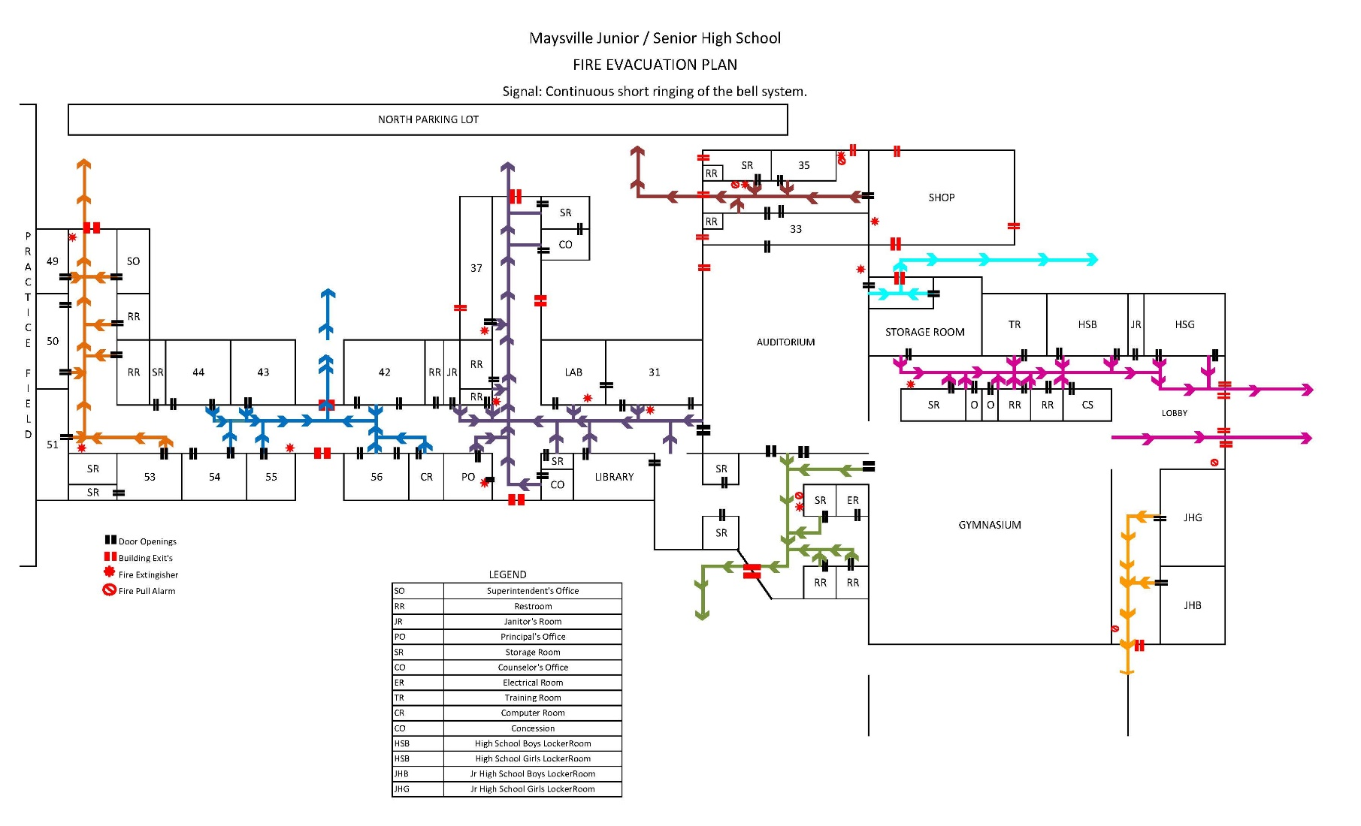

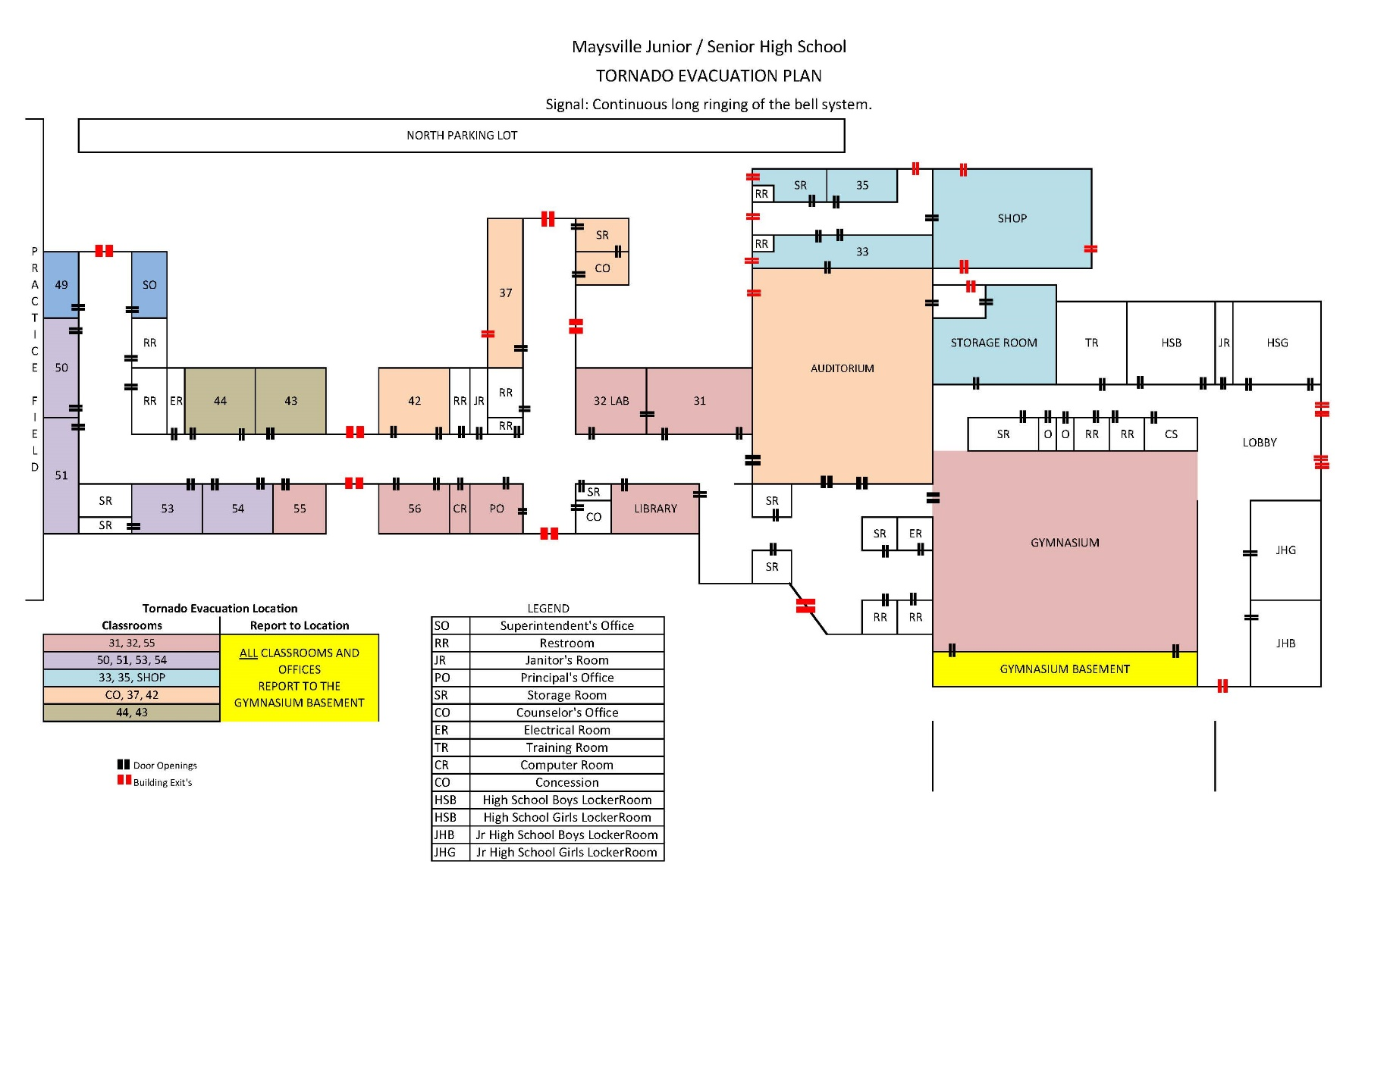

**EVACUATION ROUTES FOR THE ELEMENTARY**

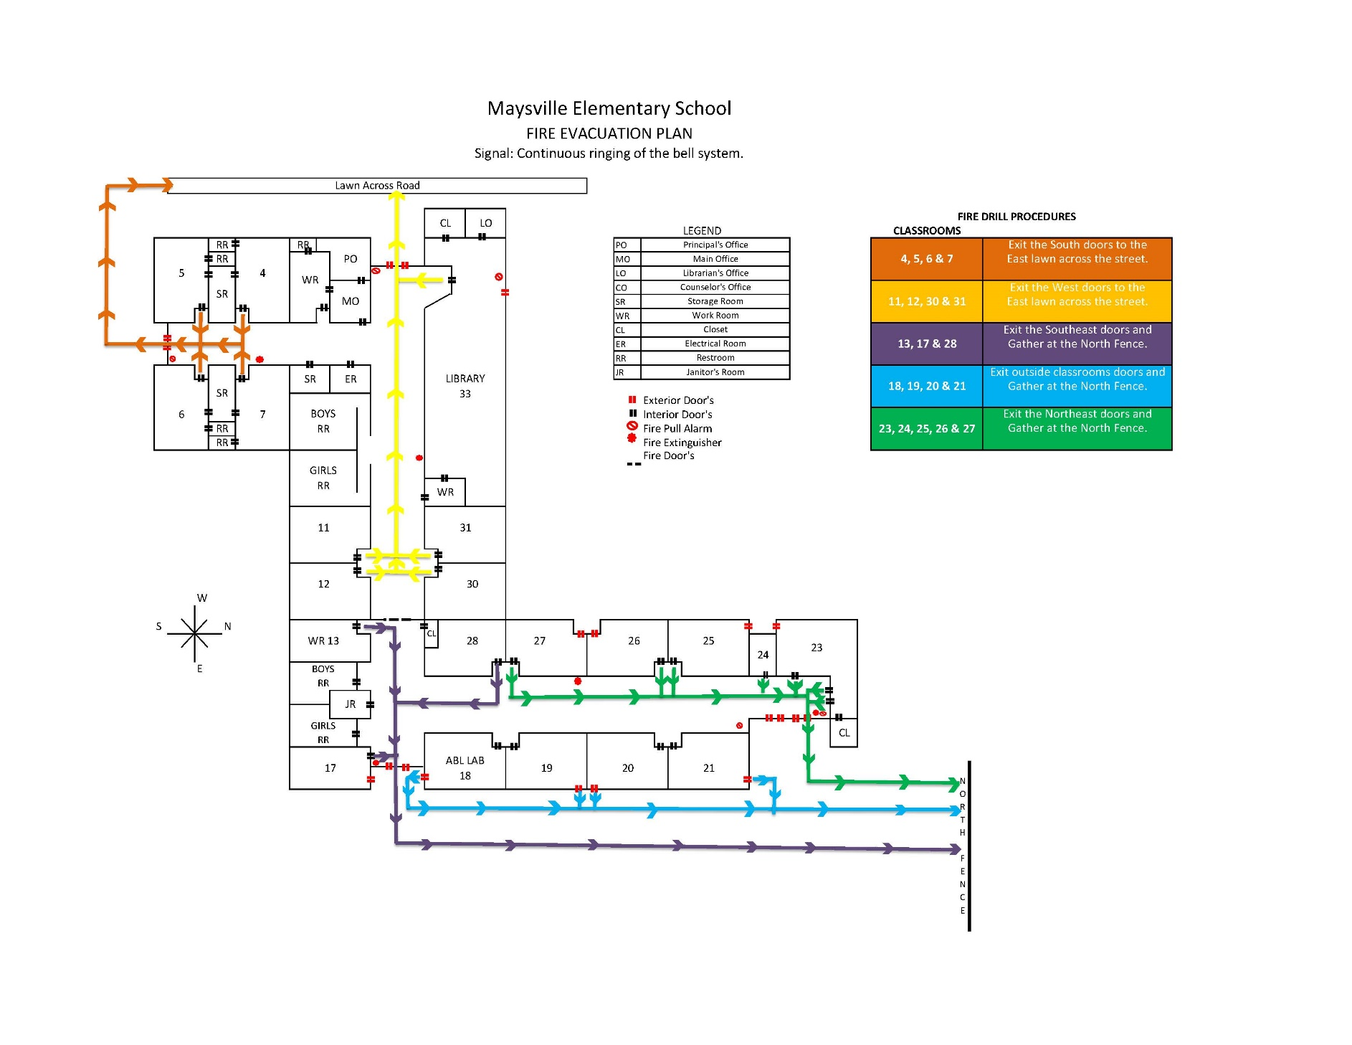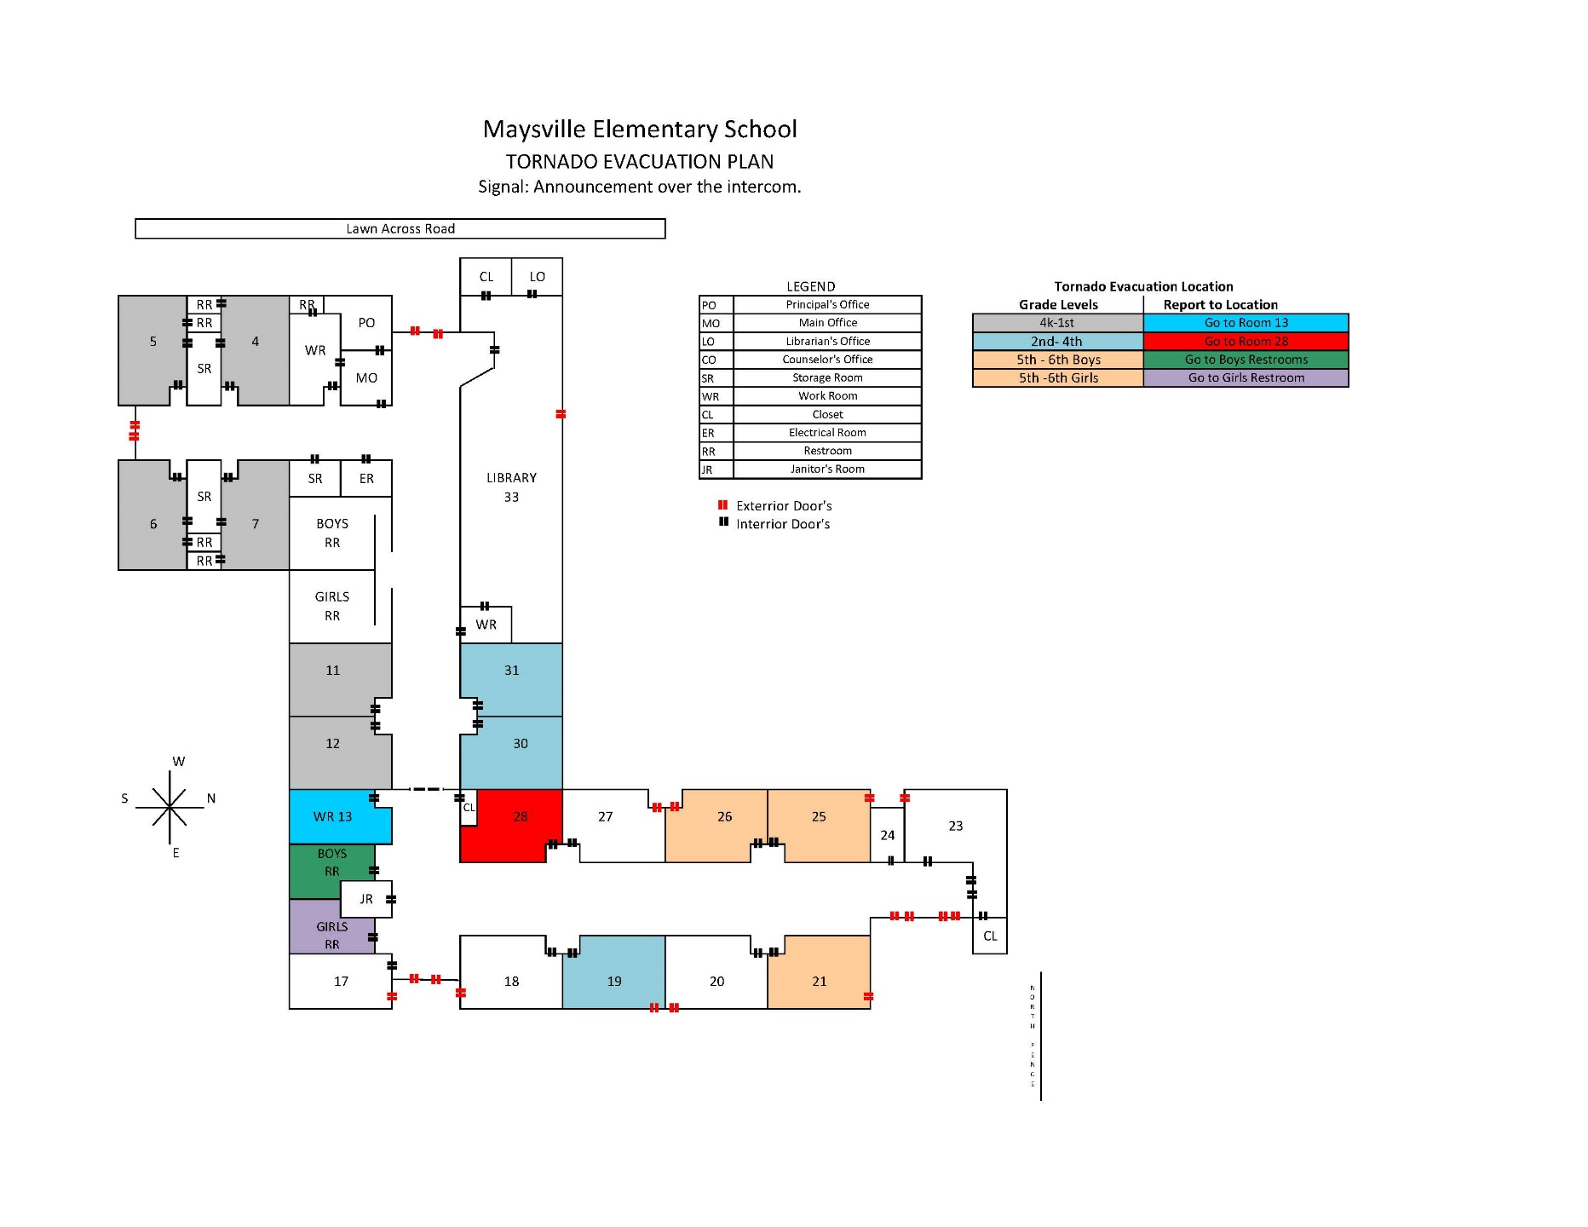

# ANNEX B

**EMERGENCY ASSISTANCE DIRECTORY**

**IN CASE OF AN EMERGENCY**

**CALL “911”**

1. GENERAL: The “Emergency Assistance Directory” is designed to provide Emergency Management personnel with a means to quickly contact key personnel, agencies and resources in times of emergency.
2. SCHOOL PRINCIPALS AND FACILITIES MANAGERS: Principals and Facilities Managers are responsible for supplying and updating community and school specific data needed to complete the directory for their school or facility. As a minimum, the directory will include the following information:

**CATEGORY OF SERVICE ORGANIZATION PHONE**

**Emergency** National Weather Service 405-366-6583

Garvin County Sheriff 405-238-7591

**911** McClain County Sheriff 405-527-2141

Oklahoma Highway Patrol 580-223-8800

Maysville Police 405-867-4447

Lindsay Police 405-756-3232

Lindsay Ambulance 405-756-4321

Purcell Ambulance/Wadley’s 405-527-5555

Non-Emergency 911 405-238-9900

**FIRE** Maysville Fire Department 405-867-4447

**911** Lindsay Fire Department 405-756-3232

**POISON**  Poison Control Center 1-800-222-1222

Oklahoma City 405-271-5454

**MISSING CHILDREN** National Center for Missing Children 1-800-843-5678

**LAW ENFORCEMENT** O.S.B.I. 405-290-7770

F.B.I. 405-290-7770

Garvin County Sheriff 405-238-7591

McClain County Sheriff 405-527-2141

Oklahoma Highway Patrol 580-223-8800 Maysville Police 405-867-4447

Lindsay Police 405-756-3232

**HEALTH/MEDICAL**  Ambulance 405-867-4447

Maysville South Central Medical 405-756-1414

Garvin County Health Dept. 405-238-7346

Poison Control Center 1-800-222-1222

Oklahoma City 405-271-5454

**UTILITIES** O.G.&E. 405-272-9595

O.G.&E. 1-800-522-6870

O.N.G. 1-800-664-5463

Telephone 1-800-843-9214

Maysville Water 405-867-4447

**SERVICE ORGANIZATIONS** American Red Cross 1-800-530-4318

Salvation Army, Ardmore 1-580-223-6176

# ANNEX C

**EMERGENCY PERSONNEL DIRECTORY**

1. GENERAL: The Emergency Assistance Directory is intended to provide users with quick access to names and phone numbers of Emergency Management Personnel within the Maysville Public Schools system.
2. SCHOOL PRINCIPALS AND FACILITIES MANAGERS: Principals and Facilities Managers are responsible for supplying and updating community and school specific data needed to complete the directory for their school or facility. As a minimum, the directory will include the following information:
3. In the event of a disaster, whether at home or at the school, notify your Emergency Coordinator or supervisor of your situation and location.
4. Shelter: When confronted with tornados, severe thunder storms, earthquake, or winter storms, seek shelter in the lowest level of a building, in a central location away from windows, and when available, under a strong table or desk.
5. Evacuate: When faced with a fire, hazardous material spill, flood, bomb threat or violence in the workplace, evacuate the building or danger area. Do not move through or into the affected area unless forced to do so.
6. Contact Numbers:

**DEPT./AGENCY NAME/POSITION PHONE NUMBER**

Maysville Public Schools Superintendent 405-867-5595

600 First Street

Maysville, OK 73057

Secondary Principal 405-867-4410

Elementary Principal 405-867-5550

Director of Maintenance 405-867-4410

# ANNEX D

**CHECKLIST FOR RECEIPT OF TELEPHONIC BOMB OR TERRORIST THREAT**

1. GENERAL: One of the characteristics of terrorists is the general need to publicize their actions. At time this may include telephonic or written warning of a bomb or other type of attack. These warnings normally occur only a short time before the event is scheduled to take place. (A copy of this Bomb Threat Checklist, should be placed under each phone within the School or Facility, for immediate use by any employee who receives the call.)
2. TELEPHONIC THREAT CHECKLIST:
3. IMMEDIATE ACTIONS:
4. Notify, without alerting the caller, a supervisor or other employee of the call and have then notify the police.
5. Remain calm and speak slowly and distinctly.
6. Do not hang up the receiver or place the caller on hold.
7. Write down the caller’s exact words.
8. Once the caller disconnects from the call (hangs up), you should hang up your receiver**. Be sure you are on the same line that received the call and immediately press *69 and be prepared to write-down the information the automatic system will give you.**  Do not share this *69 information with students.
9. Questions to Ask the Caller:
10. When is the bomb scheduled to explode?
11. Who is calling?
12. Where is the bomb located and what does it look like?
13. Why is this threat/action being taken?
14. Impressions the caller made upon you: (circle appropriate responses)

Adult/Child

Male/Female

Calm/Nervous

Accent? Type?

Stutter/Lisp

Nasal

Intoxicated

Loud/Soft

Slow/Fast

Well Spoken

Vulgar/Coarse

Disguised

1. Background Noises:
2. Text of Conversation: (write down everything you remember)

# ANNEX E

**DAMAGE ASSESSMENT CHECKLIST**

1. GENERAL: At the conclusion of an emergency situation, Emergency Coordinators will conduct a Damage Assessment of their assigned areas of responsibility for submission to the School Principal or Facilities Manager. (This damage assessment is not intended to replace required engineering, technical or detailed assessments.)

The purpose of the assessment is to provide the Superintendent with a timely estimate of the damage done to facilities and equipment in order to restore normal operations as quickly as possible.

1. DAMAGE ASSESSMENT CHECKLIST:
   * 1. Safety:
2. Structural Integrity: (Check walls, ceilings, windows, floor, any supporting structures and all overhead fixtures for cracks, breaks or other signs of weakness.)
3. Utilities: (Check all electric, gas and water fixtures/outlets for breakage or leaks.)
4. Hazardous Materials: (If any potentially hazardous materials/chemicals are stored or maintained in the work place, insure that no spills have occurred and that the integrity of storage containers remains intact.)
   * 1. Operational:
5. Furnishings: (Check for damage to organizational furniture, e.g. desks, chairs, tables, file cabinets, bookcases.)
6. Office Equipment: (Check computers, typewriters, smart boards, routers, copy machines, printers, and other equipment required for normal operations.)
7. Communications: (Check phones, fax machines and intercoms.)
8. Office Supplies: (Check availability and serviceability of expendable office materials, e.g. paper, pens, computer diskettes, ink/toner for copy machines and printers, and other materials as may be required.)
9. Records: (Check to see if important records, reference materials, and data bases are present and serviceable.)
10. Miscellaneous: (Check for damage or destruction of any other equipment or items that were present in the work area prior to the disaster but are not essential to restoration of office functions or services)

# Annex H

**School Principals Annual Emergency Management Program Status Report**

An emergency management program is characterized by visible leadership, support, endorsement, and engagement demonstrated through the elements of its program. This status report will assess the emergency management program’s administration, coordination, and stakeholder involvement.

Review and identify all elements existent for the program:

1. Identify methods and schedules for reviewing and updating emergency plans.

2. Maintain and evaluate exercises or training programs.

3. Maintain a database of resource providers.

4. Designate personnel to staff emergency functions as identified in the emergency operations plan.

5. Emergency procedures distributed with evacuation routes posted.

6. Conduct exercises and identify shortfalls.

7. Update emergency procedures if needed.

Comments:

|  |  |
| --- | --- |
|  | Comments |
| 1. |  |
| 2. |  |
| 3. |  |
| 4. |  |
| 5. |  |
| 6. |  |
| 7. |  |